THE FUTURE OF DEFAULT SERVICE:
REVIEWING THE RESTRUCTURING DEAL?

THE LOW-INCOME CONSUMER POINT OF VIEW

MASSACHUSETTS ELECTRIC RESTRUCTURING ROUNDTABLE
BOSTON
JUNE 21, 2002

Jerrold Oppenheim, Esq.
57 Middle St.
Gloucester, Mass. 01930
978-283-0897
Fax 978-283-0957
JerroldOpp@tgic.net

Source: Mass. DOER

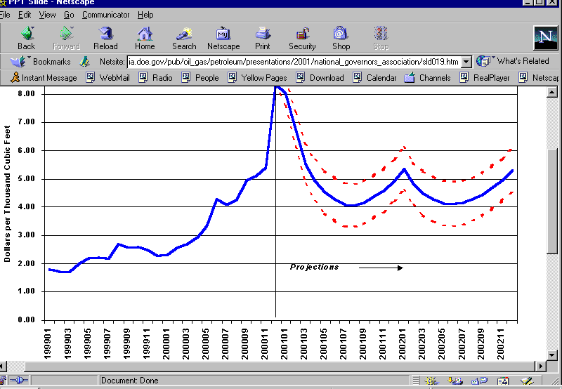

US EIA -- Natural Gas Spot Prices: Base Case and 95% Confidence Interval (dotted)
Sources: History – Natural Gas Week; Projections – Short-Term Energy Outlook, Jan. 2001

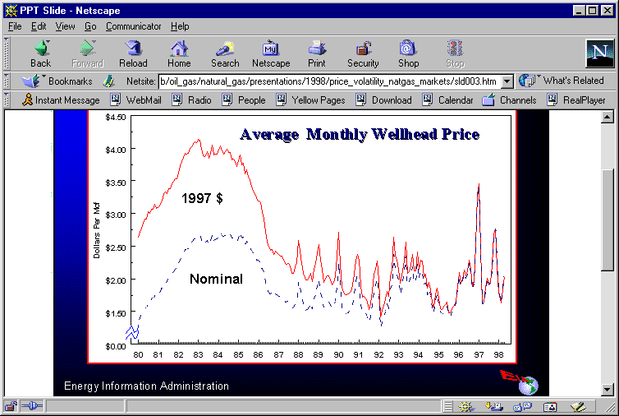

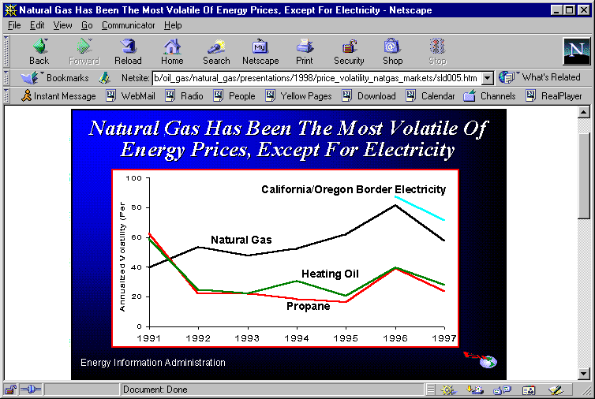

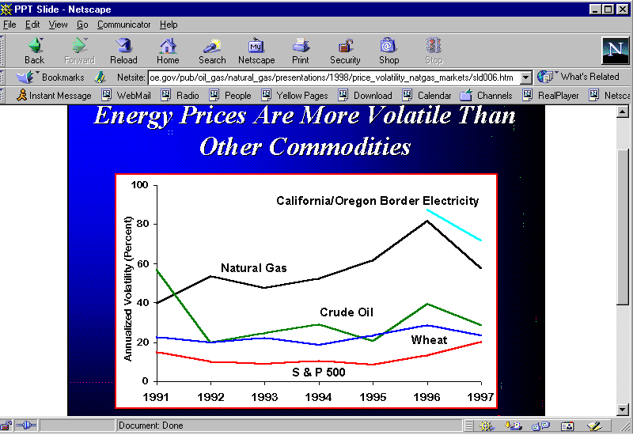

CONSUMER PRINCIPLES

- REASONABLE

- STABLE

- EXISTING PROTECTIONS

- AFFORDABLE

- ROBUST

- PERMANENT

Source: Mass. DOER

